**EXPRIMENT NO-8**

**CSA1142-OBJECT ORIENTED ANALYSIS AND DESIGN**

**SOFTWARE PERSONAL SYSTEM**

**USE CASE**

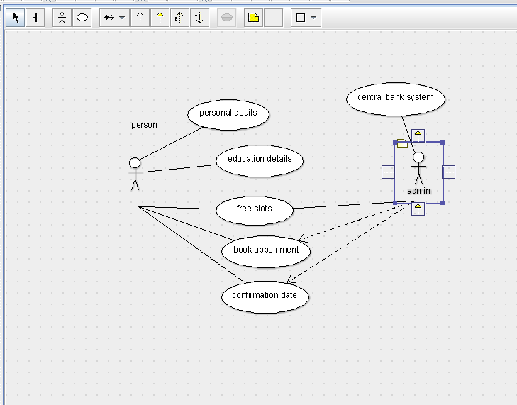

STATE DIAGRAM

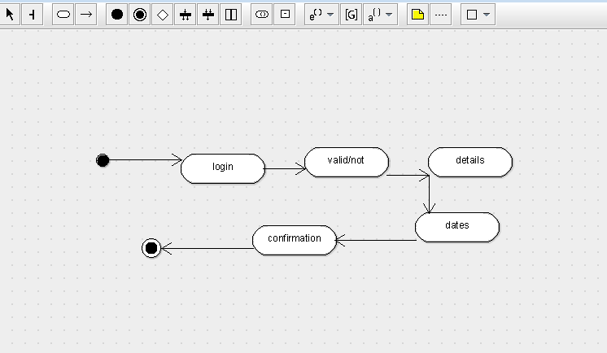

SEQUENCE DIAGRAM

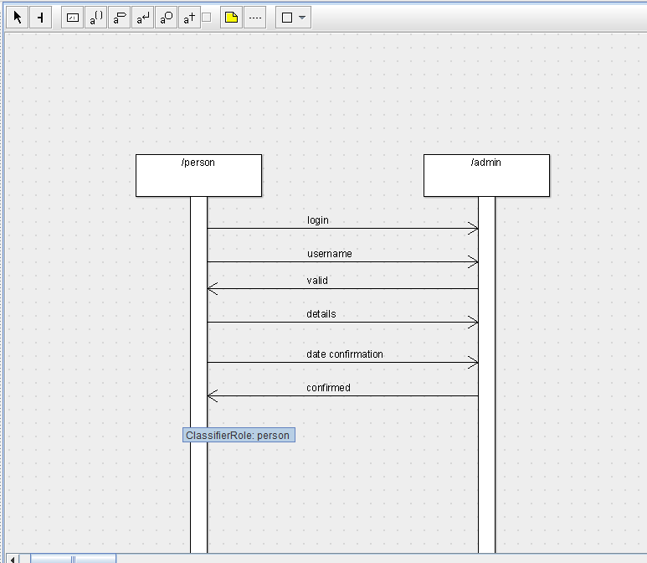

DEPLOYMENT DIAGRAM

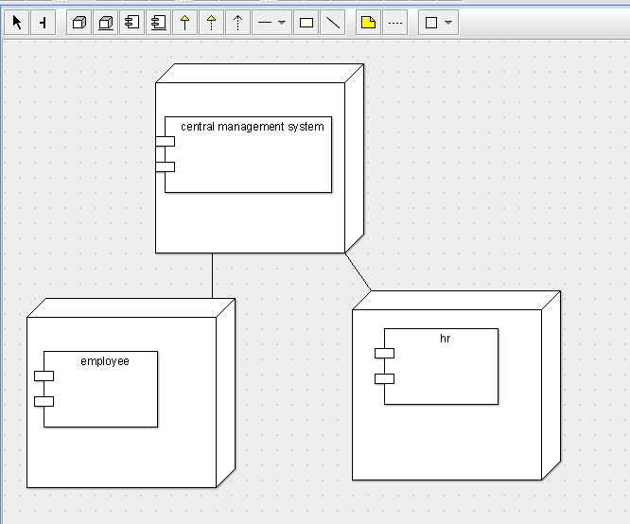

COMPONENT DIAGRAM

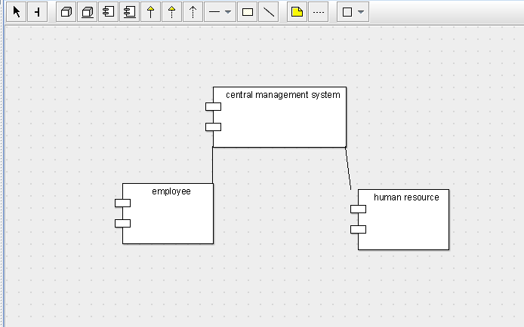

COLLABORATION DIAGRAM

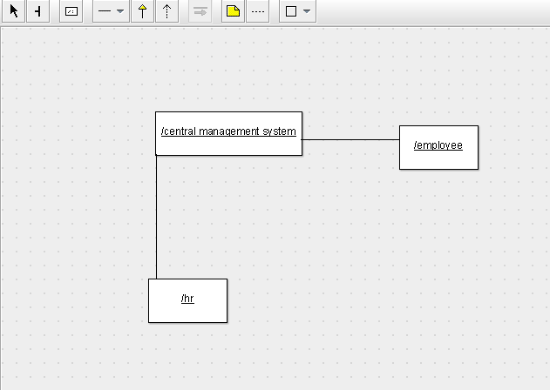

CLASS DIAGRAM

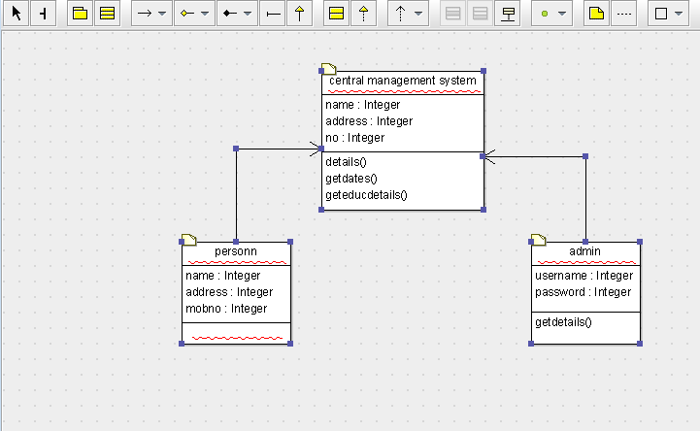

ACTIVITY DIAGRAM

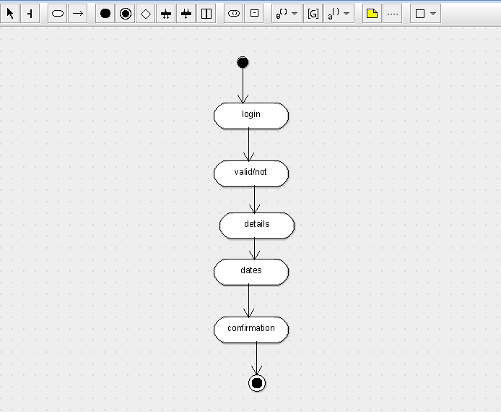

SKELETON CODE;

public class central management system {

  public Integer name;

  public Integer address;

  private Integer no;

  private void details() {

  }

  public void getdates() {

  }

  public void geteducdetails() {

  }

}

import java.util.Vector;

public class admin {

  public Integer username;

  public Integer password;

    public Vector  mycentral management system;

  public void getdetails() {

  }

}

import java.util.Vector;

public class personn {

  public Integer name;

  public Integer address;

  public Integer mobno;

    public Vector  mycentral management system;

}